Solution to Homework Assignment #2

- MoneyCo Bond Investment Problem.

- Excel Spreadsheet: MONEYCO.XLS.
We assume that all transactions occur at the beginning of the year.

Decision Variables:
X_{A} = millions of $ invested in Bond A,
X_{B} = millions of $ invested in Bond B,
X_{C} = millions of $ invested in Bond C,
X_{D} = millions of $ invested in Bond D,
X_{E} = millions of $ invested in Bond E.
We also define variables for the amount of money put into CDs at the beginning of each year. That is, let C_{i} = millions of $ available to invest in CDs at the beginning of year i, for i=1,2,3,4.

Objective Function: The objective function is to maximize the amount of cash available at the beginning of year 4, which is C₄.

Constraints: The constraints are of the “flow in = flow out” type. The amount of cash available is equal to the amount invested in bonds plus the amount invested in CDs. Or put another way, the amount of cash available minus the amount invested in bonds is equal to the amount invested in CDs. That is:

(amount available – amount invested in bonds = amount invested in CDs)
(Year 1) 1 − X_{A} − X_{B} − X_{C} = C₁
(Year 2) 1.15 X_{B} + 1.05 C₁ − X_{E} = C₂
(Year 3) 1.28 X_{C} + 1.05 C₂ − X_{D} = C₃
(Year 4) 1.40 X_{A} + 1.15 X_{D} +1.32 X_{E} + 1.05 C₃ = C₄

In addition, no more than $500,000 can be invested in any one bond. Thus:

(Limits) X_{A} ≤ 0.5, X_{B} ≤ 0.5, X_{C} ≤ 0.5, X_{D} ≤ 0.5, X_{E} ≤ 0.5.

Of course, each decision variable should be non-negative, i.e., X_{i} ≥ 0, C_{i} ≥ 0.

The complete linear program to determine the maximum amount of cash the company can generate in year 4 is:

Max C₄
subject to
(Year 1) 1 − X_{A} − X_{B} − X_{C} = C₁
(Year 2) 1.15 X_{B} + 1.05 C₁ − X_{E} = C₂
(Year 3) 1.28 X_{C} + 1.05 C₂ − X_{D} = C₃
(Year 4) 1.40 X_{A} + 1.15 X_{D} +1.32 X_{E} + 1.05 C₃ = C₄
(Limits) X_{A} ≤ 0.5, X_{B} ≤ 0.5, X_{C} ≤ 0.5, X_{D} ≤ 0.5, X_{E} ≤ 0.5.
X_{A} ≥ 0, X_{B} ≥ 0, X_{C}≥ 0, X_{D}≥ 0, X_{E} ≥ 0
C₁ ≥ 0, C₂ ≥ 0, C₃ ≥ 0, C₄ ≥ 0

In Excel, the optimized spreadsheet looks like so:
Decision Variables (in millions of $)
1
=B15+C15
Objective Function =B18+C18
=SUMPRODUCT(B9:F9,$B$4:$F$4)

=(1+$F$15)*D17

The Solver Parameters are:
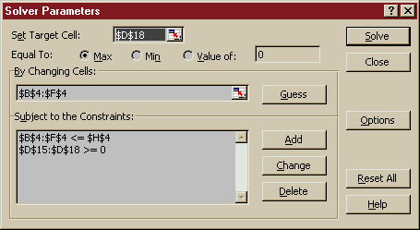
- MoneyCo can generate $1,479,000 at the beginning of year 4. To do this, they must invest:
$175,000 in Bond A,
$435,000 in Bond B,
$391,000 in Bond C,
$500,000 in Bond D,
$500,000 in Bond E.
In each year, MoneyCo invests the rest of the money available in CDs. In this example, there is no cash in CDs in any year. At the beginning of year 2, all the cash flow from Bond B is invested in Bond E. At the beginning of year 3, all the cash flow from Bond C is invested in Bond D.

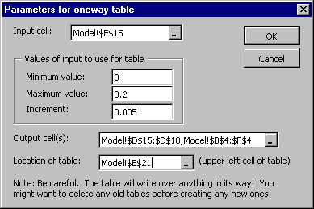
- Using a oneway SolverTable, we vary the CD rate from 0% to 20% in increments of 0.5%. The SolverTable Parameters are:

The top of the SolverTable output looks like so:

Amount in CDs in each year
Amount in each bond in each year
Total $ in year 4

The first column (column B) represents the CD rate (ranging from 0% to 20% in increments of 0.5%). Columns C, D and E are the amount invested in CDs in years 1, 2 and 3 (respectively). Column F is the objective function (the amount of cash in year 4). The last five columns represent the amount invested in each of the bonds.

For any CD rate at or below 9.0%, we never invest in CDs. For any rate at or above 15.0%, we never invest in bonds.

- In order to limit the number of bonds in the portfolio we introduce new decision variables that indicate whether the bonds are or are not part of the portfolio.

Y_{A} = 1 if Bond A, is in the portfolio, 0 otherwise
Y_{B} = 1 if Bond B, is in the portfolio, 0 otherwise
Y_{C} = 1 if Bond C, is in the portfolio, 0 otherwise
Y_{D} = 1 if Bond D, is in the portfolio, 0 otherwise
Y_{E} = 1 if Bond E, is in the portfolio, 0 otherwise

We link the new decision variables to the old decision variables by adding the constraints:

X_{A} <= Y_{A}
X_{B} <= Y_{B}
X_{C} <= Y_{C}
X_{D} <= Y_{D}
X_{E} <= Y_{E}

We now limit the number of bonds in the portfolio to at most 3.

Y_{A}+ Y_{B}+ Y_{C} + Y_{D} + Y_{E} <= 3

We restrict the new decision variables to only take binary values.

New Decision Variables (Buy Yes/No)

